Comparison and Validation of real and simulated robot system using ROS
About the project:
The project deals with the development of machine learning method to perform an assembly task using KUKA iiwa robot. The project is divided into three phases: data acquisition from simulated and real robot using ROS, model development using machine learning and experimental validation on real assembly task.
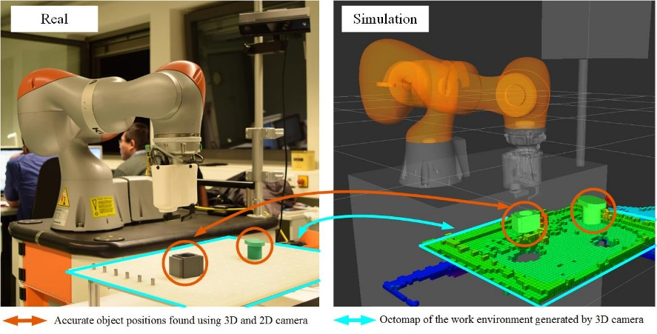
What is the to be given:
The initial phase of the project requires data acquisition using real robot and simulated robot. The simulation environment should use a Physics engine to predict the forces acting on the robot based on the CAD model of the setup. The predicted forces should match with a high accuracy (>95%) with the real setup.
What you should do:
- Develop a real time ROS interface for the KUKA iiwa robot to be simulated in V-REP.
- Compare and validate the forces acting on the real robot with the simulated robot.
- Analyze an assembly operation for real case scenario.
Skills:
The candidate should have prior knowledge about CAD software (SolidWorks or CATIA etc.).
The desired skills are knowledge in:
- Basic robot programming
- C/C++, Java
- Robot Operating System (ROS) and Ubuntu
Contact:
Dipl.-Ing. J. Philipp Städter
Lehrstuhl Automatisierungstechnik
LG 3A, Siemens-Halske-Ring 14
BTU Cottbus Senftenberg

